Changing the Image in Photoshop.

Open the downloaded Banner Set PSD files (See Picture-1)
File Menu > Open
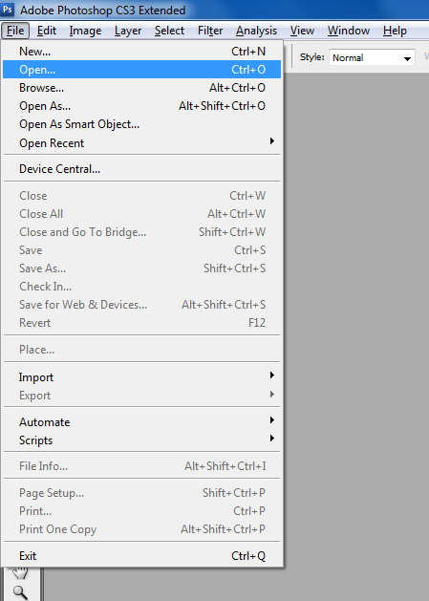 Picture-1

Then Go to layer window (See Picture-3)
Window menu > Layer (Press F7)
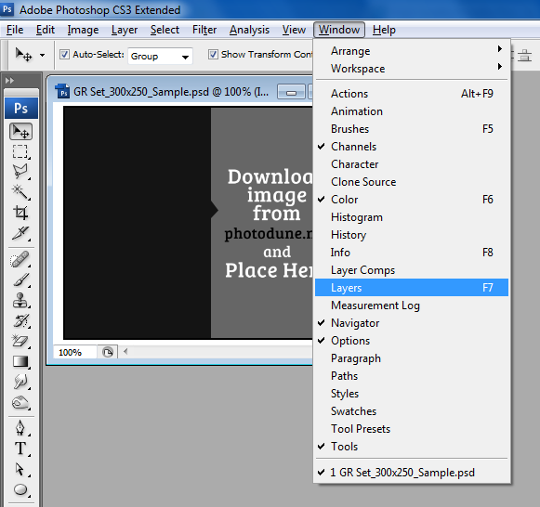 Picture-3

And now you can see some folders in layers window (See Picture-4)
Logo, Outline Border, Button, Main Text, Background, Image etc.
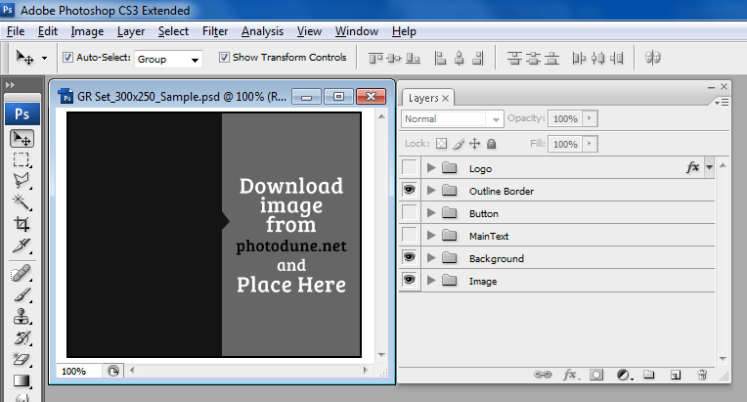 Picture-4

Open images folder in the layer window (See Picture-5)
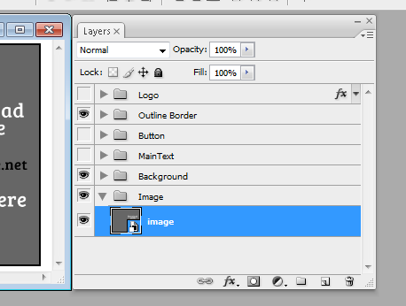 Picture-5

Double Click on the image icon (Smart object) (See Picture-6)
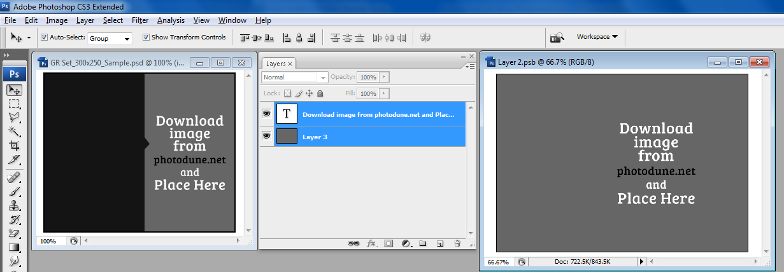 Picture-6

Now you can see the full view of the image. Then you can change this image to your own image.

Go to File Menu > Open > Select your Image
Then press “Open” Button

Then go to Tool Box > Select Move Tool and Click and drag image to above the old image layer
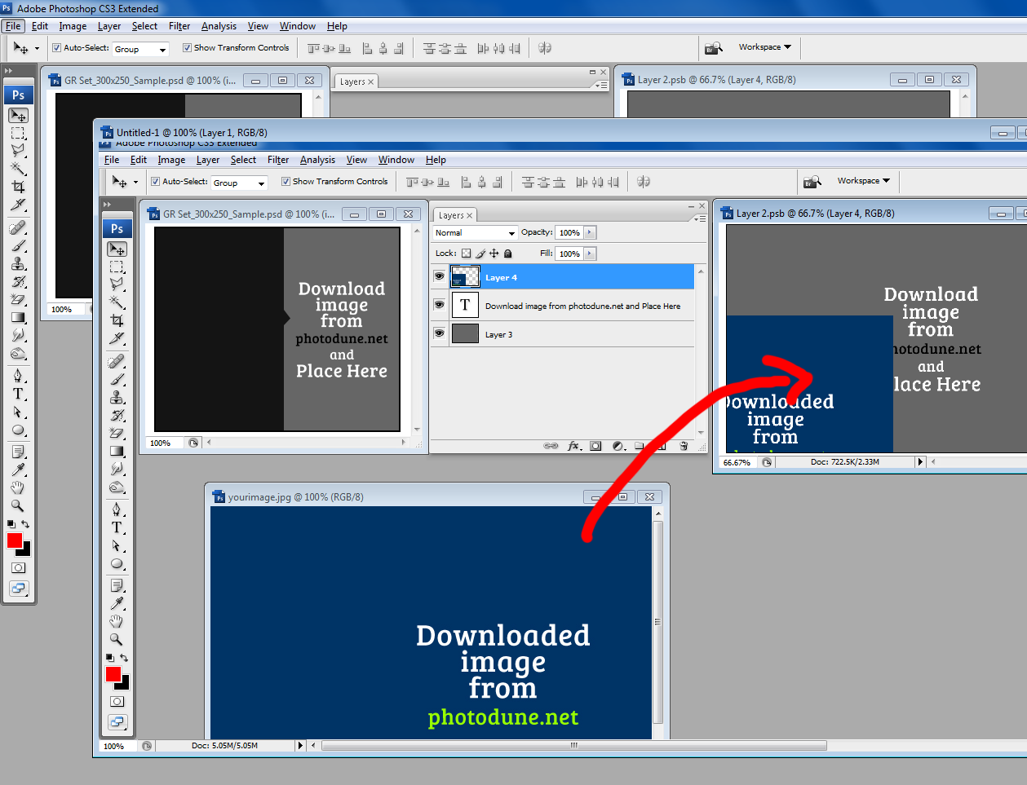

Then you can align the same Position. And Press “Close” (Image Window). Press “Yes” Button
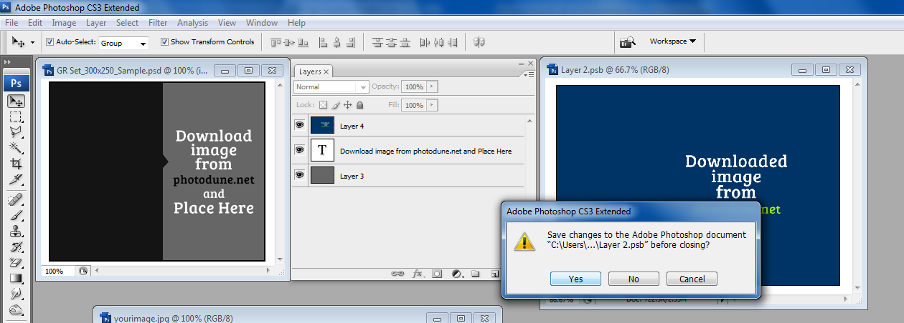

Now your image is ready.
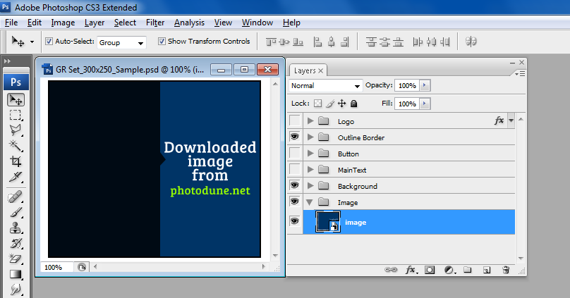

Then Save
File Menu > Save or Save As

Now you have saved the work file (psd file)

Next you if want to Save Gif or Jpg
Go to File Menu >Select on “Save for Web & Devices”
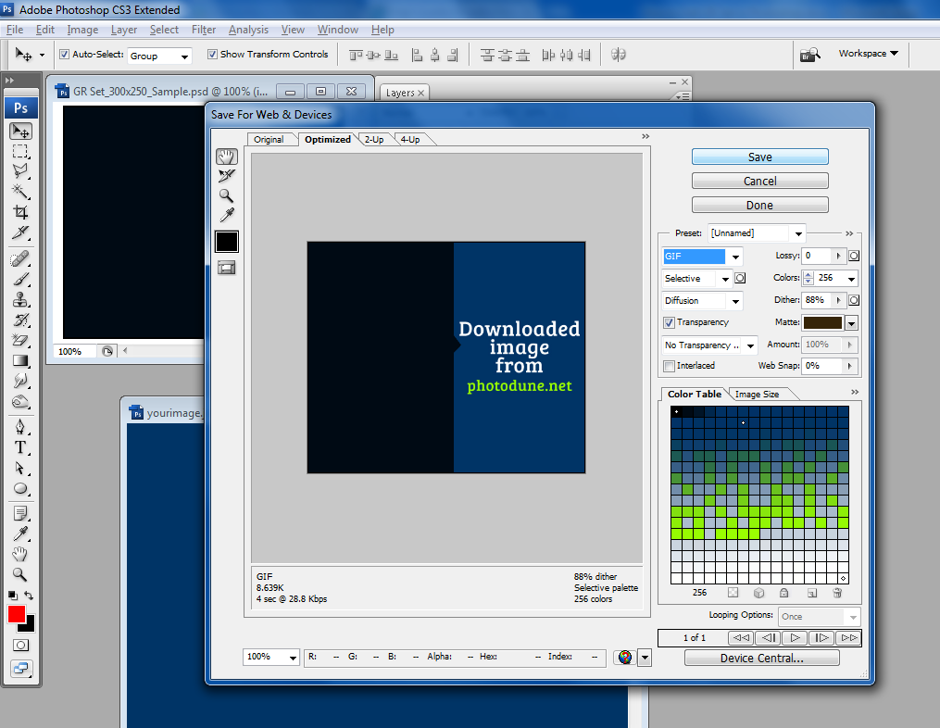

There is an option to change GIF, JPG and PNG. You can select any one then press “Save” Button

Save to your Banner folder

